No guarantees this is correct, I'm sure the mark scheme has plenty of wiggle room if you justify your choices!

MCQs -

1. C
2. B
3. D
4. A (or B???)
5. D (notes not 100% clear on which diagrams are "structural")

Scenario software engineering qs...

6. Basically pick some of these and explain why they're useful for requirement elicitation.

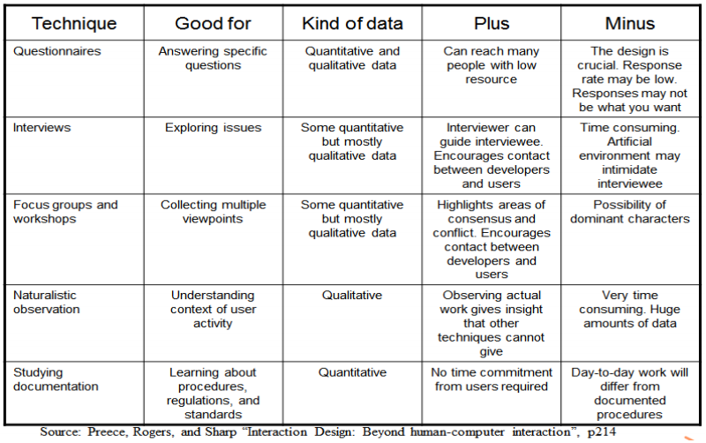

I'd lean towards giving the traders questionnaires, interviewing the clients and studying documentation.

7. Wiggle room here but I might answer -

* Waterfall - Do requirements, design, implementation, testing then maintenance once in that order. Inherently simple, easy to manage. Unsuitable for our project as we need to produce incremental prototypes (specified in question). Also unsuitable for long, ongoing projects (future deals specified in question).
* Incremental - Multiwaterfall. More expensive but fast initial product and ability to react to change.
* Prototyping - Build prototype, give to client, rebuild or add to prototype for next iteration. Fairly suitable.
* XP - Time-boxed sprints, daily meetings. Features added to product backlog and added to incremental shippable product. ROAM board deals with risks.

I would choose the Prototype as we have customer buy in to get feedback and it allows quick identification of errors and missing functionality.

8. ~~Use model-view-controller design pattern. Allows stock prices to be dynamically updated on all user devices as requested and allows traders to to dynamically update which stocks they're interested in.~~ See discussion to the right - MVC is not a pattern, it's an architecture. Best choice -

THE OBSERVER PATTERN The Observer Pattern defines a one-to-many dependency between objects so that when one object changes state, all of its dependents are notified automatically  
Alternatives from notes -

STRATEGY PATTERN

DECORATOR PATTERN

ADAPTER PATTERN

9.

Number of Problems: Use software, think-aloud and record list of problems.

Emotional state of users: If the user is upset, something is wrong!

User Opinions: Surveys, questionnaires on a simple scale (both, pre-test and post-test)

This affects the prototyping loop as we get user feedback after building each prototype.

10. Risk management processes -

|  |  |
| --- | --- |
| Processes Involved | What it does |
| Risk Identification | List precisely all risk events possible in a project |
| Risk Analysis | Define probability of occurrence, potential for loss |
| Risk Planning | Preventive measures to reduce likelihood or impact of risk event |
| Risk Monitoring | Match measures to re-calculated probabilities |

11. Size estimation - can estimate by analogy to similar projects, can estimate by count compute if/once historical data available. eg, look at total features, average time per feature so far, estimate remaining time.